
CP&M CELL, BSNL Corporate Office,
Room No. 614, Bharat Sanchar Bhawan,
Janpath, New Delhi – 110001.

Tel: 91-11-23326021
Fax: 91-11-23351291
e-mail: ltp@bsnl.co.in

No..1-2 (1)/Revenue Share/ 2012-CP&M Dated 23.03.2012

Sub: Analysis of Circle Wise Revenue Growth along with BSNL Revenue Growth and Market Share for the Quarter ending December 2011 of F.Y. 2011-12.

- This is with reference to the Quarterly Gross Revenue figure earned by the telecom sector as published in the TRAI website for all operators. Based on the data available for the quarter ending December 2011 and the unaudited report received from CA Cell for BSNL, the detailed information at the Operator level has been compiled and is attached at Annexure-1.

- The Annexure-2 analyses the growth of the revenue on the Y-o-Y basis circle wise,for the period April-December based on the TRAI report. The data also compares the circle wise BSNL growth vis-à-vis the industry growth during this period and calculate the gaps between the two.

- The key findings of the analysis are:

  - Total Revenue (Annexure-1):
    - BSNL revenue for the third quarter (Q3 2011-12) stood at Rs 5,686 Cr against industry revenue of Rs. 48,480 Cr with market share of 11.73%, behind Airtel (28.20%), Vodafone (19.32%) and Idea (11.96%).
    - The industry revenue on Q-o-Q (Q2 to Q3) basis has grown by 4.76% against which BSNL revenue decline by -17.41%, a gap of 22.17%.
    - The industry revenue on Y-o-Y basis for the period (April – December) has grown from Rs. 1,26,896 Cr to Rs 1,41,923 Cr, an increase of 11.84%. During the same period, BSNL revenue has decrease from Rs 20,253 Cr to Rs 19,711 Cr, a decrease of (-)2.68%.

  - Zonal wise, Circle Wise Revenue Growth of Industry vis-à-vis growth of BSNL (Annexure-2):

3.2.1 Zonal Analysis:
- South Zone is the largest contributor to the total revenue with share of (33.5%) followed by North Zone (26.9%), West Zone (21.7%) and East Zone (17.8%).
- The growth of industry vis-à-vis growth of BSNL on Y-o-Y basis for the period April – December in the four zones along with gap, in the increasing order of gap is given below:
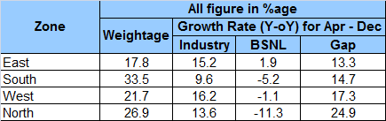

    - Analysis of South Zone:
- Top three Circles in terms of Weight age: The top three Circles in order of contribution are Andhra Pradesh, Tamil Nadu and Karnataka.
- The License area wise growth of the industry vis-à-vis growth of BSNL on Y-o-Y basis for the period April to December along with the gap, in the increasing order of gap, is given below:
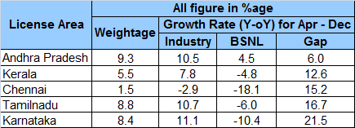
- The top three Circles registering highest growth (Y-o-Y) for the industry is: Karnataka (11.1%), Tamilnadu (10.7%) and Andhra Pradesh (10.5%). Comparatively, the growth of BSNL in these circles are Karnataka (-10.4%), Tamilnadu (-6.0%) and Andhra Pradesh (4.5%).

    - Analysis of North Zone:
- Top three Circles in terms of Weight age: The top three Circles in order of contribution are UP(East), Rajasthan and UP (West).
- The License area wise growth of the industry vis-à-vis growth of BSNL on Y-o-Y basis for the period April to December along with the gap, in the increasing order of gap, is given below:
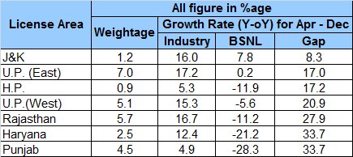

- The top three Circles registering highest growth (Y-o-Y) for the industry is: UP(East) (17.2%), Rajasthan (16.7%) and J&K (16.0%). Comparatively, the growth of BSNL in these circles are UP(East) (0.2%), Rajasthan (-11.2%) and J&K (7.8%).

    - Analysis of West Zone:
- Top three Circles in terms of Weight age: The top three Circles in order of contribution are Maharashtra, Gujarat and Madhya Pradesh.
- The License area wise growth of the industry vis-à-vis growth of BSNL on Y-o-Y basis for the period April to December along with the gap, in the increasing order of gap, is given below:
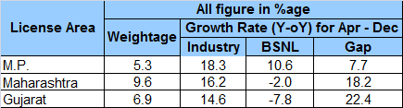

- The top three Circles registering highest growth (Y-o-Y) for the industry is: Madhya Pradesh (18.3%), Maharashtra (16.2%) and Gujarat (14.6%). Comparatively, the growth of BSNL in these circles are Madhya Pradesh (10.6%), Maharashtra (-2%) and Gujarat (-7.8%).

    - Analysis of East Zone:
- Top three Circles in terms of Weight age: The top three Circles in order of contribution are Bihar, West Bengal and Kolkata.
- The License area wise growth of the industry vis-à-vis growth of BSNL on Y-o-Y basis for the period April to December along with the gap, in the increasing order of gap, is given below:
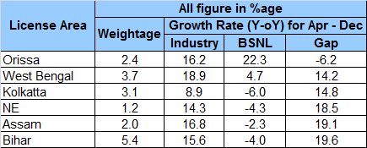

- The top three Circles registering highest growth (Y-o-Y) for the industry is: West Bengal (18.9%), Assam (16.8%) and Orissa (16.2%). Comparatively, the growth of BSNL in these circles are West Bengal (4.7%), Assam (-2.3%) and Orissa (22.3%).

Encl: Annexure-1&2.

(SANJEEV VERMA) DGM (CP&M)

To
- CMD, BSNL for information please.
- Dir (CFA)/ Dir(HR)/ Dir(Enterprise)/ Dir(CM) for information please.
- ED (CA)/ ED(F)/ ED(CN)/ ED(NB) for information for information please.
- All CGMs (Telecom Circles) / (Metro District) for information and further action please. (Through Intranet)
- All PGMs / Sr GMs / GMs of Corporate Office. (Through Intranet)

------------------------------------------------------------------------------------------------------------------------------------------------------------
Regd Office : Bharat Sanchar Bhawan, Harish Chandra Mathur Lane, Janpath, New Delhi-1 Website: www.bsnl.co.in

